The Geeks
Sprint 2 Documentation

Requirements Backlog
- The system shall authenticate all users using Google as a third-party identity provider. (completed)
- The system shall assign all new users a default role of Applicant upon registration. (completed)
- The system shall allow Master Admin to assign roles (Admin or Provider) to users. (completed)
- The system shall allow providers to post learnership/internship opportunities (title, description, stipend, location, duration, requirements, closing date). (completed)
- The system shall allow admins to approve or remove opportunity listings. (completed)
- The system shall allow providers to view all opportunities they have created
- The system shall allow applicants to create a profile and upload a CV.
- The system shall allow applicants to apply for multiple opportunities.
- The system shall allow providers to shortlist or reject applications.
- The system shall track application status for applicants.
- The system shall send notifications (in-app and email) at each stage of the application process.
- The system shall notify users of new matching opportunities.
- The system shall notify users of upcoming closing dates.
- The system shall provide dashboards for analytics.
- The system shall allow custom views of reports.
- The system shall allow reports to be exported as CSV or PDF.

Sprint 2 User Stories

User Story 1: View opportunities
As a provider, I want to view opportunities I have created so that I can check their statuses
Tasks:
- Show all opportunities that a provider has created together with their status (Assigned: Ozuko, Status: completed)
UAT:
- Given I am a provider
- When I view opportunities, I have created
- Then I should see their statuses

User Story 2: Resubmit Opportunity
As a provider, I want to resubmit a rejected opportunity so that it can be reviewed
Tasks:
- Implement resubmitting an opportunity (Assigned: Musa, Status: completed )
UAT:
- Given I am a provider
- When I resubmit an opportunity
- Then it should be available for review

User Story 3: Create Profile
As an applicant, I want to create a profile so that I can use it when applying for an opportunity
Tasks:
- Add personal details, education, and skills fields to the user schema (Assigned: Dikeledi, Status: completed)
- Create the profile page (Assigned: Dikeledi, Status: completed)
- Allow applicants to enter their details and save their profile (Assigned: Dikeledi, Status: completed )
UAT:
- Given I am an applicant
- When I create a profile
- Then I should be able to use it when applying

User Story 4: Edit Profile
As an applicant, I want to edit my profile so that it can have latest changes.
Tasks:
- Implement edit applicant profile (Assigned: Thendo, Status: completed )
UAT:
- Given I am an applicant
- When I edit my profile
- Then it should update to latest changes

User Story 5: Submit Application
As an applicant, I want to submit an application to an opportunity so that it is available for consideration
Tasks:
- Submit application using the applicant’s profile and CV (Assigned: Musa, Status: completed )
- Link the application to the applicant and opportunity (Assigned: Musa, Status: completed )
- Allow applicants to submit their application (Assigned: Musa, Status: completed )
- Show applications to the provider who created the opportunity (Assigned: Musa, Status: completed )

UAT:
- Given I am an applicant
- When I create an application
- Then providers should be able to see it

User Story 6: Application Status
As an applicant, I want to view applications I have submitted so that I can check their statuses
Tasks:
- Show an applicant all their applications together with their status (Assigned: Tlhalefo, Status: completed)
UAT:
- Given I am an applicant
- When I view my applications
- Then I should see their statuses

User Story – Requirement Traceability Matrix
This section provides a traceability mapping between the system’s user stories and the corresponding documented requirements defined for the project.

- The system shall allow providers to view all opportunities they have created
- The system shall allow applicants to create a profile and upload a CV.
- The system shall allow applicants to apply for multiple opportunities.

User Story 1: View opportunities
Requirement Linked: Opportunity Listings -> The system shall allow providers to view all opportunities they have created.
User Story 2: Resubmit Opportunity
Requirement Linked: Opportunity Listings -> The system shall allow providers to post learnership/internship opportunities.
User Story 3: Create Profile
Requirement Linked: Applicant Profiles -> The system shall allow applicants to create a profile and upload a CV.
User Story 4: Edit Profile
Requirement Linked: Applicant Profiles -> The system shall allow applicants to create a profile and upload a CV.
User Story 5: Submit Application
Requirement Linked: Applicant Profiles -> The system shall allow applicants to apply for multiple opportunities.
User Story 6: Application Status
Requirement Linked: Applicant Profiles -> The system shall allow applicants to apply for multiple opportunities.
_________________________________________________________________________________

SPRINT 2 MEETING 1 MINUTES
The Geeks — SA Learnerships and Skills Development Portal
Project | The Geeks — SA Learnerships and Skills Development Portal
Meeting Type | Assignment Of Functionalities
Date | 14 April 2026
Start Time | 21h00
End Time | 22h00
Recorded by | Tlhalefo Sebaeng
Signed off by | 2575338 | 2585063

Attendees
Dikeledi, Ozuko, Thendo, Tlhalefo

Absent
Musawenkosi

Agenda
Sprint 1 review
Sprint 2 deliverables
Product backlog review

Discussion Points

Sprint 1 review
- The team reviewed sprint 1 and discussed what went wrong and what we can fix.
- Dikeledi suggested that we set a minimum arrival time for each meeting in such a way that if a person does not arrive before that time, we will consider that person absent for that meeting.

Sprint 2 deliverables
- Tlhalefo took everyone through what we need to complete for sprint 2. Most of the things remain the same as in sprint 1; however, we need to write unit tests for this sprint and do UML diagrams for our product so far

Development progress
- Tlhalefo apologized for that and told the team that he will try to deploy as soon as possible, as this was not done before the sprint 1 deadline.
- Tlhalefo notified the team that although all the user stories that the team had for sprint 1 were successfully implemented, there are still a few bugs/issues to be fixed, so the issue tracker on GitHub should still be used for that.
- The team decided that everyone will make sure that there are few to no bugs for the features they implemented in sprint 1.

Product backlog review
- The team reviewed the product backlog and pulled some requirements into sprint 2.
- The team then decided on the 6 new user stories to complete for sprint 2

Task assignment
- Each member then chooses the user stories that they will complete. In this sprint each member will complete user stories together with their tasks.
- Each member will write unit tests for the part they were working on and ensure that a minimum of 65 code coverage is met on their branch.

Deadlines
- The deadline for all assigned tasks is 16 April 2026 (Thursday)

Action Items
Task | Owner
Complete assigned tasks by 16 April 2026. | All members
Deploy the app to Azure and set up a CI/CD pipeline | Tlhalefo

Next Meeting: Thursday, 16 April 2026 at 12h00 @ MSL Discussion Rooms
SCREENSHOT:

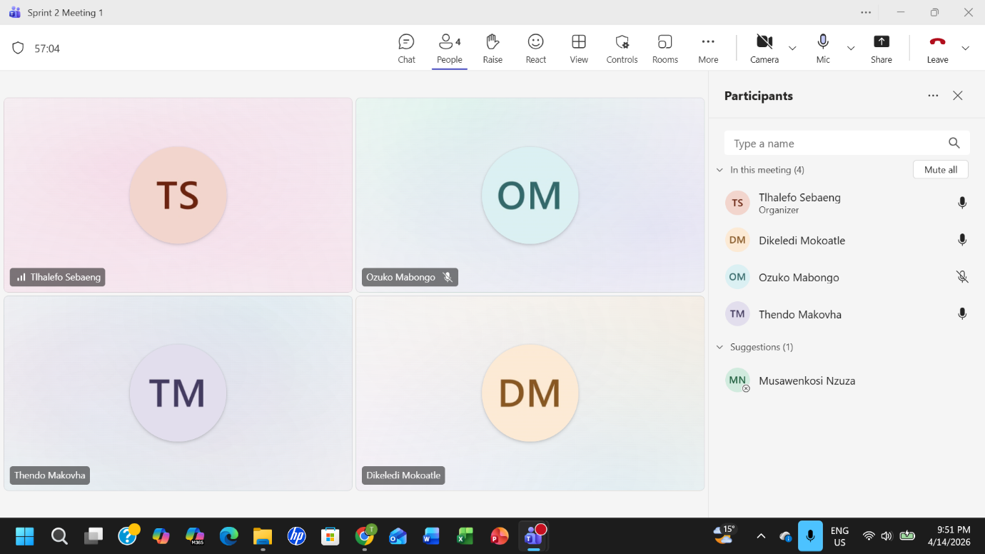

_________________________________________________________________________________
SPRINT 2 MEETING 2 MINUTES
The Geeks — SA Learnerships and Skills Development Portal
Project | The Geeks — SA Learnerships and Skills Development Portal
Meeting Type | Progress Update Session
Date | 16 April 2026
Start Time | 12h00
End Time | 12h40
Recorded by | Ozuko Mabongo
Signed off by | 2768437 |

Attendees
All members attended
Agenda
Presentations on the tasks completed so far and discussion of encountered issues.

Discussion Points
Project Progress Updates
- Ozuko Mabongo:
Provided an update on her current progress. She confirmed that her backend is working, but the frontend is not yet connected, and she also added that she added a creator field to the opportunity schema and related controllers, which allows the system to track who created each opportunity.

- Dikeledi Mokoatle:
Provided an update on the profile update functionality; she did most of the work already, and since editing and creating a profile are basically the same thing when using MongoDB, we decided that Thendo is going to work with Dikeledi to find bugs on the last part, which is submitting the changes. She also created a route to get the current logged-in user details and created a middleware to confirm the JWT token.

- Thendo Makovha:
Provided an update on the editing a profile but since Dikeledi did the most part already and they were doing similar thing, they decided that they are going to help each other with finding bugs on submitting the changes, he also raised concerns about the consistency of user stories specifically the “benefit” clause since the benefit of a user story should primarily link back to the main actor not secondary actors, to maintain consistency across the project. He also reminded the group to include necessary bridge entities and avoid shortcuts in code, since he needs to accurately represent the system structure in the diagrams.

- Tlhalefo Sebaeng:
Provided an update on testing and deploying code. He asked the group to test his deployment and raise issues in the issue tracker on GitHub. He noted that his work depends on Musawenkosi’s progress (specifically for viewing application statuses).

- Musawenkosi Nzuza:
Musa attended the meeting but had to leave shortly after since he had a class at the time.
Action Items
Task | Owner
Rewrite user stories to ensure the benefit serves the primary actor, finalize and document the new user story for editing rejected opportunities. Work on CV functionality. | Thendo
Connect frontend to backend. | Ozuko
Fix the edit and create profile functionality. | Dikeledi
Complete creating and application functionality. | Musawenkosi
Test Thlalefo’s deployment and raise issues on the issue tracker. | All members
Pull all work to meet the 12:00 PM deadline | All members
SCREENSHOT: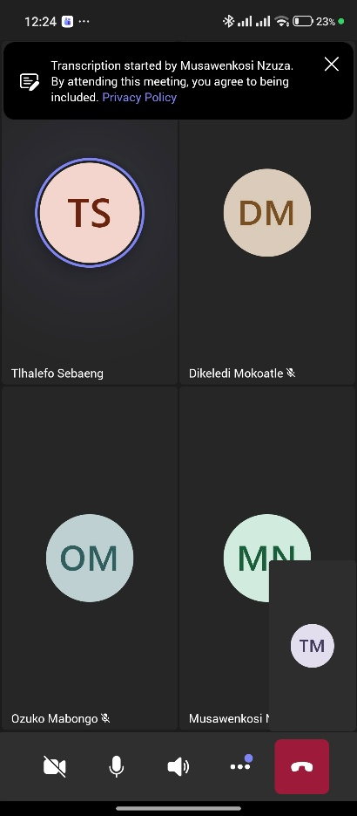

Next Meeting: Friday, 17 April 2026 at 20h00 @ Microsoft Teams

_________________________________________________________________________________

SPRINT 2 MEETING 3 MINUTES
The Geeks — SA Learnerships and Skills Development Portal
Project | The Geeks — SA Learnerships and Skills Development Portal
Meeting Type | Progress Update Session
Date | 17 April 2026
Start Time | 20h00
End Time | 21h00
Recorded by | Mokoatle Dikeledi
Signed off by | 2769106 | 2768437

Attendees
Dikeledi, Ozuko, Thendo, Tlhalefo

Absent
Musawenkosi

Agenda
Presentations on the tasks completed so far and discussion of encountered issues.

Discussion Points

Project Progress Updates
- Ozuko:
Provided an update on her current progress. She confirmed that her code is functional; however, she occasionally experiences an issue where opportunities do not display, and the system becomes slow. She is currently investigating the cause of this issue and aims to resolve it by the end of the following day.

- Dikeledi:
Provided an update that the profile update functionality is working as expected. Remaining work includes implementing deletion functionality for skills and opportunities.

- Thendo:
Provided an update on the CV upload feature. He mentioned that he was unable to fully test the feature due to issues with Google login and registration on his branch. He plans to fix the issue and present a complete update at the next meeting.

- Tlhalefo:
Provided an update on testing efforts. He is currently working on improving test coverage and plans to provide an update in the next meeting.

Action Items
Task | Owner
Debug and resolve performance/display issue in opportunities feature | Ozuko
Implement deletion functionality for skills and opportunities in the profile page. | Dikeledi
Complete testing of the CV upload feature | Thendo
Improve test coverage | Tlhalefo
Catch up on missed updates and integrate feedback from the team | Musawenkosi

Next Meeting: Sunday, 19 April 2026 at 20h00 @ Microsoft Teams

SCREENSHOT:

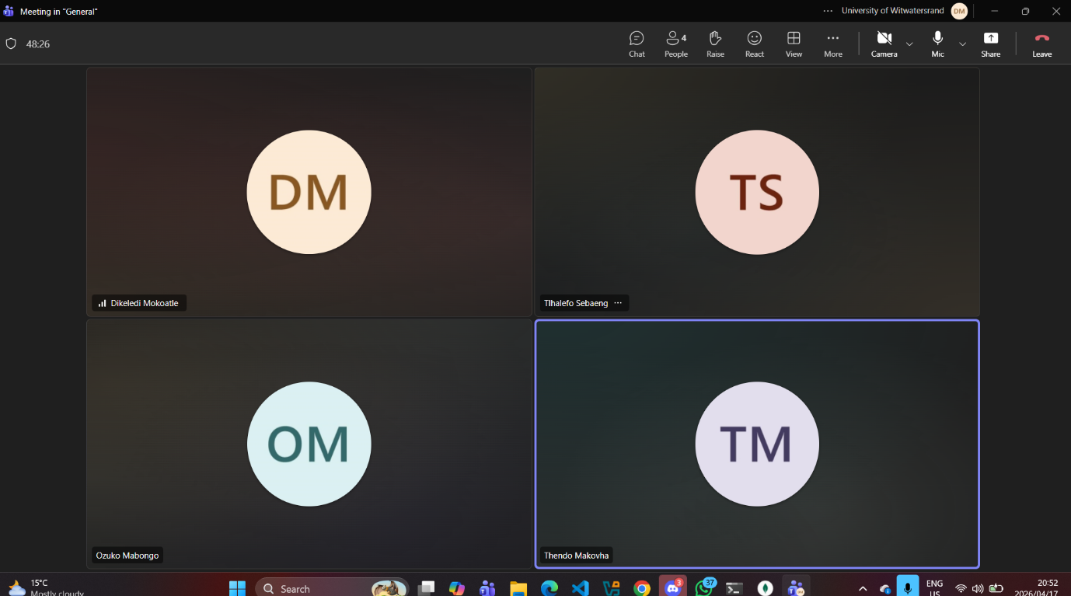

_________________________________________________________________________________
SPRINT 2 MEETING 4 MINUTES
The Geeks — SA Learnerships and Skills Development Portal
Project | The Geeks — SA Learnerships and Skills Development Portal
Meeting Type | Code Review & Sprint Progress Check
Date | 19 April 2026
Start Time | 20h00
End Time | 21h00
Recorded by | Makovha Thendo
Signed off by | 2575338 | 2585063

Attendees
Dikeledi, Ozuko, Thendo, Tlhalefo, Musawenkosi

Agenda
Review of implemented code, UML alignment, user stories completion status, testing progress, and preparation for the upcoming presentation.

Discussion Points
Code Review & UML Alignment
● The team reviewed the current codebase to ensure alignment with the UML diagrams (use case, activity, sequence, state machine, class, and deployment diagrams).
● It was confirmed that most backend and frontend components are consistent with the designed architecture.
● Minor mismatches were identified between some user story flows and implementation logic, which will be corrected before final submission.
User Stories Review
● The team evaluated completed user stories to check if requirements have been satisfied.
● Most core user stories for applicants, providers, and administrators have been implemented successfully.
● Remaining gaps were identified in edge cases such as validation handling and error feedback improvements.
Testing & Code Coverage
●Progress on test-driven development (TDD) was reviewed.
● Unit tests have been implemented for key backend functions, but coverage is still incomplete in some modules.
● The team agreed to improve test coverage, especially for authentication and application submission features.
● Existing tests in the repository were reviewed and updated where necessary.
Preparation for Presentation
● The team discussed preparation for the upcoming Sprint presentation.
● Responsibilities were divided to ensure each member presents their assigned components (UML diagrams, backend, frontend, and testing).
● A dry-run presentation will be conducted before the official presentation to ensure consistency and confidence.
Action Items
Task | Owner
Ensure all sprint meeting proof is submitted | All members
Debug remaining code blocks for tomorrows presentation | All members
Fix mismatches between UML and implementation logic | Thendo
Improve test coverage | Tlhalefo

SCREENSHOT:



